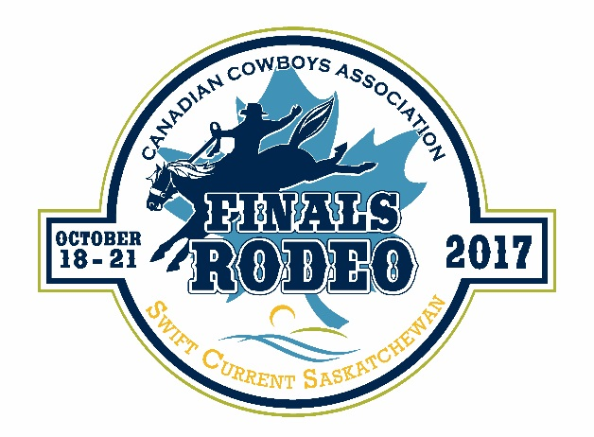

Canadian Cowboys Association Finals Rodeo
Event Sponsorship Coordinator

Position: Event Sponsorship Coordinator
Contract

Company: Canadian Cowboys Association Finals Event Committee (CCA)
177 1st Ave NE, Swift Current, SK

Salary: Proposals in the form of Retainer and/or Commission will be accepted

Timeframe: June 1, 2017 until December 31, 2017 (renewal option for 3 years)

Job Description:
Reporting to the Finance Chair, the Event Sponsorship Coordinator will work with the Canadian Cowboys Association Finals Committee to solicit and implement the Event Finals Sponsorship program. In 2015, the City of Swift Current was awarded the Canadian Cowboy Association Event Finals for a five year time period for the 2016, 2017, 2018, 2019 and 2020 finals. The Canadian Cowboys Association Event Finals Committee is a non-profit board dedicated to ensuring a successful and professional Canadian Cowboys Association Finals Rodeo. A success that includes the safety and comfort of the following: rodeo competitors, contractors, rodeo stock, workers, judges, media, family, friends, patrons, trade show exhibitors, cabaret goers, community members and fans. The CCA Event Finals Rodeo is comprised of seven major events and four optional novice and junior events.

Primary duties of the Event Sponsorship Coordinator include:
- Implementation of sponsorship program:
  - Development and oversight of corporate sponsor relationships and agreements
  - Scheduling, coordination and documentation of year-round communications with corporate sponsors
  - Actively identify, research and cultivate a list of prospective partners
  - Creation of sponsor materials, including letters, power point presentations, proposals, contracts, etc.
  - Fulfillment of all sponsorship deliverables, including signage, tickets, etc.
  - Work with all committee members and partners to ensure fulfillment and activation of sponsorship agreements before, during and after event

  - Advise the Event Finals Marketing Coordinator of website requirements for sponsor logos/listings
  - Ensure that sponsors are included in the message of marketing materials, including social media, news releases, etc.
- Assist with coordination of CCA Event Finals Rodeo production
  - Coordinate with all critical parties to create daily rodeo production timelines
- Management of the Rodeo Uncorked Event:
  - Sponsor and fan based event held during CCA Event Finals
- Coordinate sponsor sign production and installation
- Follow CCA Event Finals budgets and timelines

Applicants should possess the following abilities:
- Education: preference will be given to individuals with
marketing/communications/agriculture background
- Knowledge and experience in Event Sponsorship
- Positive and outgoing attitude
- Strong verbal and written communication skills
- Self-starter and team player
- Detail oriented and strong organizational skills
- Proficient in Microsoft Word, Excel and PowerPoint
- Adobe Creative Suite experience preferred
- Be Safe Places Certified

Individuals interested in a rewarding experience with the CCA Event Finals Rodeo must submit (via e-mail or drop off) cover letter, resume, contract proposal and list of references no later than Thursday May 11, 2017 to:
Community Services
C/O Finance Chair – Canadian Cowboys Association Event Finals Committee
177 1st Ave NE – City Hall
Swift Current, SK
S9H 3W1
306-778-2787
communityservices@swiftcurrent.ca

Any individual who does not submit a cover letter, resume, contract proposal and list of references will not be considered for the position. We thank all applicants, however, only those candidates selected for further consideration will be contacted.

